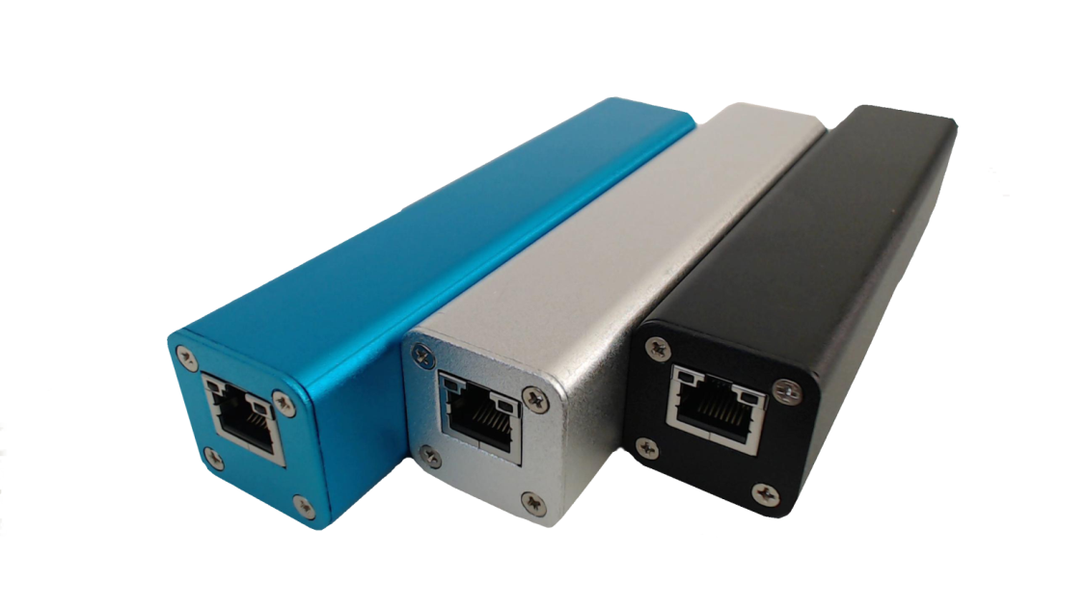

255 Centrum Blvd., Suite 102

Ottawa, Ontario K1E 3W3

613.366.3055 ph / fax

www.wawtechnologies.com

* **Advanced Threat Detection**
  + internal IDS
  + data leakage
  + botnet detection
  + worm detection
* **Network Visibility and Security**
  + communication monitoring
  + data leakage
* **Compliance** 
  + (HIPAA, PCI, FISCA, SCADA, ITSG-33)
  + QoS monitoring
* **Network Troubleshooting and Planning**
  + enterprise-wide view of network traffic usage
  + planning for capacity upgrades and elimination of bottlenecks
* **Forensics and Investigations**
  + continuous, flow-based information
  + attack history reconstruction
  + reporting on one, or on multiple users
* **Industry**
  + continuous industrial process monitoring

WAW Technologies’ flagship product, **NEWT**, is an intelligent, small form factor security appliance that can be installed in-line, at the endpoint equipment. It delivers real-time, host-level insight of activities and behaviors for individual workstations, servers and any other IP-based devices on the network.

**NEWT** helps address common network challenges and is fully interoperable with commercial network data collectors such as IsarFlow, Fluke, Cisco, Dartware, AdventNet, Arbor Networks, Plixer, NetFlow Auditor, SolarWinds Orion NTA, etc.

**NEWT – Network Explorer Wire Tap**

**BENEFITS**

**sophisticated data capture and reporting**

**leveraging of flow data collected at the endpoints**

**visibility into security control failures**

**ability to fill in the gaps left by perimeter security solutions**

**better understanding of network architecture**

**in-depth, enterprise-wide view of network traffic use**

**identification of behavioral-based anomalies**



**delivers continuous flow-based information**

**allows network and security teams to run tailored flow queries**

**eliminates network blind spots**

**brings accountability and measurability to network use**

**maintains the forensically clean state of endpoints**

**conduct security investigations with granularity configurable from entire network visibility to a single user**

**identify problems in a timely manner**

**reconstruct the history of a compromise**



**provides actionable intelligence**

**"plug-and-play" functionality requires no infrastructure changes**

**lower cost unobtrusive alternative to existing enterprise grade solutions**